Informatica quizzes

|  |  |  |
| --- | --- | --- |
| **Correct** |  |  |

|  |  |  |  |
| --- | --- | --- | --- |
| 1) | | Which Component of informatica is used to configure connection details | |
|  | |  | |
|  | | A. | Workflow Monitor |
|  | | B. | Mapping Designer |
|  | | C. | Workflow Manager |
|  | | D. | Repository Manager |
|  | | E. | Worklet Designer |
| **Incorrect** | | | |  |  |

|  |  |  |
| --- | --- | --- |
| 2) | By default, the PowerCenter Server sets the number of partitions to | |
|  |  | |
|  | A. | 1 |
|  | B. | 2 |
|  | C. | 3 |
|  | D. | 4 |
|  | E. | I don't know |
|  | Discuss this Question | |  |

|  |  |  |
| --- | --- | --- |
| **Correct** |  |  |

|  |  |  |  |
| --- | --- | --- | --- |
| 3) | | The Repository Manager connects to the repository database through the Repository Server. | |
|  | |  | |
|  | | A. | Depends upon the User |
|  | | B. | FALSE |
|  | | C. | TRUE |
|  | | D. | Only at some times |
|  | | E. | I don't know |
| **Correct** | | |  |  |

|  |  |  |
| --- | --- | --- |
| 4) | How the repository server communicates with the repository database | |
|  |  | |
|  | A. | Through native drivers |
|  | B. | Third party softwares |
|  | C. | LAN Drivers |
|  | D. | Logical Paths |
|  | E. | I don't know |

|  |  |  |
| --- | --- | --- |
| **Incorrect** |  |  |

|  |  |  |  |
| --- | --- | --- | --- |
| 5) | | What will be returned if the username and password are incorrect in a command | |
|  | |  | |
|  | | A. | 0 |
|  | | B. | Zero Return Codes |
|  | | C. | 2 |
|  | | D. | Non Zero return Codes/7 |
|  | | E. | 1 |
|  | | Discuss this Question | |  |
| **Incorrect** | | | | |  |  |

|  |  |  |
| --- | --- | --- |
| 6) | What are the types of sources available in informatica | |
|  |  | |
|  | A. | Cobol and XML sources |
|  | B. | Flatfiles |
|  | C. | Homogeneous& Heterogeneous |
|  | D. | 2&3 |
|  | E. | None |
|  | Discuss this Question | |  |

|  |  |  |
| --- | --- | --- |
| **Correct** |  |  |

|  |  |  |  |
| --- | --- | --- | --- |
| 7) | | Last 3 performer in a department need to loaded in a target table. Which transformation can be used? | |
|  | |  | |
|  | | A. | Aggregator Transformation |
|  | | B. | Expression transformation |
|  | | C. | Rank Transformation |
|  | | D. | Update Strategy |
|  | | E. | None |
| **Incorrect** | | | |  |  |

|  |  |  |
| --- | --- | --- |
| 8) | What is the session property enabled when update strategy is used in a mapping | |
|  |  | |
|  | A. | DD_INSERT |
|  | B. | DD_DELETE |
|  | C. | DD_UPDATE |
|  | D. | Data Driven |
|  | E. | DD_REJECT |
|  | Discuss this Question | |  |

|  |  |  |
| --- | --- | --- |
| **Incorrect** |  |  |

|  |  |  |  |
| --- | --- | --- | --- |
| 9) | | Flat file lookup is one newly added feature in Informatica PowerCenter 7.1version | |
|  | |  | |
|  | | A. | Depends upon the User |
|  | | B. | NO |
|  | | C. | I don't know |
|  | | D. | Only at some times |
|  | | E. | YES |
|  | | Discuss this Question | |  |
| **Correct** | | | |  |  |

|  |  |  |
| --- | --- | --- |
| 10) | Which component is used for New server registration in informatica | |
|  |  | |
|  | A. | Designer |
|  | B. | Workflow Manager |
|  | C. | 2&3 |
|  | D. | Repository Manager |
|  | E. | Repository administration console |

|  |  |  |
| --- | --- | --- |
| **Incorrect** |  |  |

|  |  |  |  |
| --- | --- | --- | --- |
| 11) | | Before you run a workflow, the informatica server needs to be registered with | |
|  | |  | |
|  | | A. | Workflow Manager |
|  | | B. | Workflow Monitor |
|  | | C. | Repository Manager |
|  | | D. | Designer |
|  | | E. | Web Interface |
|  | | Discuss this Question | |  |
| **Correct** | | | |  |  |

|  |  |  |
| --- | --- | --- |
| 12) | The process of converting and summarizing operational data into a consistent, business oriented format | |
|  |  | |
|  | A. | Transformation |
|  | B. | Extraction |
|  | C. | Loading |
|  | D. | None |
|  | E. | Option 1, Option 2 & Option 3 |

|  |  |  |
| --- | --- | --- |
| **Incorrect** |  |  |

|  |  |  |  |
| --- | --- | --- | --- |
| 13) | | If you want to use the same object in several projects, you need to put it in a shared folder | |
|  | |  | |
|  | | A. | Depends upon the User |
|  | | B. | FALSE |
|  | | C. | TRUE |
|  | | D. | Only at some times |
|  | | E. | I don't know |
|  | | Discuss this Question | |  |
| **Incorrect** | | | | |  |  |

|  |  |  |
| --- | --- | --- |
| 14) | Which window in desginer is used to access the repositories. | |
|  |  | |
|  | A. | Output |
|  | B. | Workspace |
|  | C. | Navigation |
|  | D. | Mapping desginer |
|  | E. | None |
|  | Discuss this Question | |  |

|  |  |  |
| --- | --- | --- |
| **Incorrect** |  |  |

|  |  |  |  |
| --- | --- | --- | --- |
| 15) | | How many types of Transformations available in Informatica 9.0 | |
|  | |  | |
|  | | A. | 12 |
|  | | B. | 18 |
|  | | C. | 3 |
|  | | D. | 6 |
|  | | E. | 4 |
|  | | Discuss this Question | |  |
| **Incorrect** | | | | |  |  |

|  |  |  |
| --- | --- | --- |
| 16) | What are the servers available in informatica | |
|  |  | |
|  | A. | Informatica Server |
|  | B. | Workflow Server |
|  | C. | Informatica repository Server |
|  | D. | Option 1 & Option 3 |
|  | E. | Option 1 & Option 2 |
|  | Discuss this Question | |  |

|  |  |  |
| --- | --- | --- |
| **Correct** |  |  |

|  |  |  |  |
| --- | --- | --- | --- |
| 17) | | Using session properties, can we able to override parameters established in the mapping ? | |
|  | |  | |
|  | | A. | Depends upon the User |
|  | | B. | NO |
|  | | C. | YES |
|  | | D. | Only at some times |
|  | | E. | I don't know |
| **Incorrect** | | | |  |  |

|  |  |  |
| --- | --- | --- |
| 18) | By executing the read query directly against the source database, what can be identified | |
|  |  | |
|  | A. | Source bottlenecks |
|  | B. | Target bottlenecks |
|  | C. | Mapping bottlenecks |
|  | D. | Parameter bottlenecks |
|  | E. | I don't know |
|  | Discuss this Question | |  |

|  |  |  |
| --- | --- | --- |
| **Correct** |  |  |

|  |  |  |  |
| --- | --- | --- | --- |
| 19) | | Whenever you're checking in an object, the repository version number is | |
|  | |  | |
|  | | A. | Decreased |
|  | | B. | Increased |
|  | | C. | Not changed |
|  | | D. | Reset to 0 |
|  | | E. | I don't know |
| **Correct** | | |  |  |

|  |  |  |
| --- | --- | --- |
| 20) | Can we able to start and stop a workflow from workflow monitor | |
|  |  | |
|  | A. | YES |
|  | B. | NO |
|  | C. | Depends on the privileges |
|  | D. | Only at some times |
|  | E. | I don't know |

|  |  |  |
| --- | --- | --- |
| **Incorrect** |  |  |

|  |  |  |  |
| --- | --- | --- | --- |
| 21) | | For comparing two folders, what is the mandatory permission a user should have. | |
|  | |  | |
|  | | A. | Read |
|  | | B. | Write |
|  | | C. | Execute |
|  | | D. | Super User |
|  | | E. | Administrator |
|  | | Discuss this Question | |  |
| **Correct** | | | |  |  |

|  |  |  |
| --- | --- | --- |
| 22) | Can sequence generator be used  in Mapplet desginer | |
|  |  | |
|  | A. | Yes |
|  | B. | No |
|  | C. | Rarely |
|  | D. | Sometimes |
|  | E. | None |

|  |  |  |
| --- | --- | --- |
| **Correct** |  |  |

|  |  |  |  |
| --- | --- | --- | --- |
| 23) | | If we export a mapping, session or workflow will create | |
|  | |  | |
|  | | A. | DAT File |
|  | | B. | REP File |
|  | | C. | XML File |
|  | | D. | Cache File |
|  | | E. | I don't know |
| **Incorrect** | | | |  |  |

|  |  |  |
| --- | --- | --- |
| 24) | The Workflow Monitor displays workflows that have run | |
|  |  | |
|  | A. | Never |
|  | B. | Once |
|  | C. | Twice |
|  | D. | Thrice |
|  | E. | I don't know |
|  | Discuss this Question | |  |

|  |  |  |
| --- | --- | --- |
| **Incorrect** |  |  |

|  |  |  |  |
| --- | --- | --- | --- |
| 25) | | With the error tracing level enabled, the Informatica Server logs each row that passes into the mapping | |
|  | |  | |
|  | | A. | Normal |
|  | | B. | Terse |
|  | | C. | Verbose init |
|  | | D. | Verbose data |
|  | | E. | I don't know |
|  | | Discuss this Question | |  |
| **Incorrect** | | | | |  |  |

|  |  |  |
| --- | --- | --- |
| 26) | Is it possible to join two flat files using source qualifier | |
|  |  | |
|  | A. | No |
|  | B. | Yes |
|  | C. | Sometimes |
|  | D. | Rarely |
|  | E. | Frequently |
|  | Discuss this Question | |  |

|  |  |  |
| --- | --- | --- |
| **Correct** |  |  |

|  |  |  |  |
| --- | --- | --- | --- |
| 27) | | When you configure partitioning for a mapping, which partition type distributes data evenly among all partitions. | |
|  | |  | |
|  | | A. | Hash |
|  | | B. | Key Range |
|  | | C. | Round Robin |
|  | | D. | Pass Through |
|  | | E. | I don't know |
| **Incorrect** | | | |  |  |

|  |  |  |
| --- | --- | --- |
| 28) | To debug a mapping, you need to configure and run the Debugger from | |
|  |  | |
|  | A. | Designer |
|  | B. | Workflow Manager |
|  | C. | Workflow Monitor |
|  | D. | Repository Manager |
|  | E. | I don't know |
|  | Discuss this Question | |  |

|  |  |  |
| --- | --- | --- |
| **Incorrect** |  |  |

|  |  |  |  |
| --- | --- | --- | --- |
| 29) | | How many permission types are available for folders | |
|  | |  | |
|  | | A. | 1 |
|  | | B. | 3 |
|  | | C. | 5 |
|  | | D. | 7 |
|  | | E. | 9 |
|  | | Discuss this Question | |  |
| **Incorrect** | | | | |  |  |

|  |  |  |
| --- | --- | --- |
| 30) | Can the source qualifier is used to filter cobol source | |
|  |  | |
|  | A. | No |
|  | B. | Yes |
|  | C. | Sometimes |
|  | D. | Rarely |
|  | E. | Frequently |
|  | Discuss this Question | |  |

|  |  |  |
| --- | --- | --- |
| **Incorrect** |  |  |

|  |  |  |  |
| --- | --- | --- | --- |
| 31) | | When the Server runs in recovery mode, it continues to commit data from the point of the last successful commit | |
|  | |  | |
|  | | A. | Only at some times |
|  | | B. | Depends upon the user |
|  | | C. | TRUE |
|  | | D. | FALSE |
|  | | E. | I don't know |
|  | | Discuss this Question | |  |
| **Correct** | | | |  |  |

|  |  |  |
| --- | --- | --- |
| 32) | Is it necessary to run the Informatica server before accessing Repository | |
|  |  | |
|  | A. | Yes |
|  | B. | No |
|  | C. | May be true |
|  | D. | Sometimes |

|  |  |  |
| --- | --- | --- |
| **Correct** |  |  |

|  |  |  |  |
| --- | --- | --- | --- |
| 33) | | Which Transformation is used to join flat file and oracle source | |
|  | |  | |
|  | | A. | Joiner Transformation |
|  | | B. | Union Transformation |
|  | | C. | Source Qualifier |
|  | | D. | Option 1 & Option 2 |
|  | | E. | Option 2 & Option 3 |
| **Correct** | | |  |  |

|  |  |  |
| --- | --- | --- |
| 34) | Select  a  transformation used to load  the changed records in target table | |
|  |  | |
|  | A. | Source Qualifier |
|  | B. | Filter Transformation |
|  | C. | Normalizer Transformation |
|  | D. | Expression Transformation |
|  | E. | Update Strategy |

|  |  |  |
| --- | --- | --- |
| **Correct** |  |  |

|  |  |  |  |
| --- | --- | --- | --- |
| 35) | | How many internal tools available with Workflow manager to help you develop a workflow | |
|  | |  | |
|  | | A. | 1 |
|  | | B. | 3 (task developer, wf designer, worklet dsgn.) |
|  | | C. | 5 |
|  | | D. | 7 |
|  | | E. | 9 |
| **Incorrect** | | | |  |  |

|  |  |  |
| --- | --- | --- |
| 36) | For executing a workflow, the PowerCenter server uses the | |
|  |  | |
|  | A. | Designer |
|  | B. | DLM Process |
|  | C. | DTM Process |
|  | D. | DLF Process |
|  | E. | I don't know |
|  | Discuss this Question | |  |

|  |  |  |
| --- | --- | --- |
| **Correct** |  |  |

|  |  |  |  |
| --- | --- | --- | --- |
| 37) | | Can a command task can be re-used | |
|  | |  | |
|  | | A. | Depends on the privileges |
|  | | B. | NO |
|  | | C. | YES |
|  | | D. | Only at some times |
|  | | E. | I don't know |
| **Incorrect** | | | |  |  |

|  |  |  |
| --- | --- | --- |
| 38) | How to over ride the default order by clause in lookup query | |
|  |  | |
|  | A. | Add required ORDER BY clause and add -- (double highphen at the end of lookup query override |
|  | B. | Add required ORDER BY clause in lookup query override |
|  | C. | Add required ORDER BY clause and add // (double slashes) at the end of lookup query override |
|  | D. | Don’t add lookup condition only add lookup query override |
|  | E. | None |
|  | [Discuss this Question](https://www.proprofs.com/discuss/q/624280/how-to-over-ride-the-default-order-by-clause-in-lookup-query) | |  |

|  |  |  |
| --- | --- | --- |
| **Correct** |  |  |

|  |  |  |  |
| --- | --- | --- | --- |
| 39) | | Is it possible to generate a table in relational database using informatica | |
|  | |  | |
|  | | A. | Yes |
|  | | B. | No |
|  | | C. | Sometimes |
|  | | D. | May be possible |
|  | | E. | None |
| **Correct** | | |  |  |

|  |  |  |
| --- | --- | --- |
| 40) | How many types of Workflow variables are available ? | |
|  |  | |
|  | A. | 0 |
|  | B. | 1 |
|  | C. | 2 (pre-defined, user-defined) |
|  | D. | 3 |
|  | E. | 4 |

|  |  |  |
| --- | --- | --- |
| **Incorrect** |  |  |

|  |  |  |  |
| --- | --- | --- | --- |
| 41) | | Which Transformation is used to load the rejected records | |
|  | |  | |
|  | | A. | Source Qualifier |
|  | | B. | Only Filter Transformation |
|  | | C. | Only Router Transformation |
|  | | D. | Option 2 & Option 3 |
|  | | E. | 1,2&3 |
|  | | Discuss this Question | |  |
| **Correct** | | | |  |  |

|  |  |  |
| --- | --- | --- |
| 42) | Versioning is a concept where you can configure the repository to store multiple versions of objects | |
|  |  | |
|  | A. | Only at some times |
|  | B. | Depends upon the user |
|  | C. | TRUE |
|  | D. | FALSE |
|  | E. | I don't know |

|  |  |  |
| --- | --- | --- |
| **Incorrect** |  |  |

|  |  |  |  |
| --- | --- | --- | --- |
| 43) | | To help you determine which column caused the row to be rejected,  the server adds this components to reject files | |
|  | |  | |
|  | | A. | Key Ranges |
|  | | B. | Row & Column Indicator |
|  | | C. | Mapping Parameters |
|  | | D. | Mapping Variables |
|  | | E. | I don't know |
|  | | Discuss this Question | |  |
| **Incorrect** | | | | |  |  |

|  |  |  |
| --- | --- | --- |
| 44) | A worklet is an object that represents a set of | |
|  |  | |
|  | A. | Mappings |
|  | B. | Tables |
|  | C. | Synonyms |
|  | D. | Tasks |
|  | E. | Web reports |
|  | Discuss this Question | |  |

|  |  |  |
| --- | --- | --- |
| **Incorrect** |  |  |

|  |  |  |  |
| --- | --- | --- | --- |
| 45) | | When we finetune session performance, we can use | |
|  | |  | |
|  | | A. | Test session option |
|  | | B. | Test load option |
|  | | C. | Test Log option |
|  | | D. | Test Monitor option |
|  | | E. | I don't know |
|  | | Discuss this Question | |  |
| **Incorrect** | | | | |  |  |

|  |  |  |
| --- | --- | --- |
| 46) | Using the repository manager, the entire repository can be backed up in the format of | |
|  |  | |
|  | A. | Text file |
|  | B. | Zip File |
|  | C. | XML File |
|  | D. | Binary File |
|  | E. | I don't know |
|  | Discuss this Question | |  |

|  |  |  |
| --- | --- | --- |
| **Correct** |  |  |

|  |  |  |  |
| --- | --- | --- | --- |
| 47) | | Is it possible to run the workflow from particular task | |
|  | |  | |
|  | | A. | Yes |
|  | | B. | No |
|  | | C. | Rarely |
|  | | D. | Sometimes |
|  | | E. | None |
| **Correct** | | |  |  |

|  |  |  |
| --- | --- | --- |
| 48) | The two types of loading available in DWH are | |
|  |  | |
|  | A. | Full Load |
|  | B. | Direct Load |
|  | C. | Incremental Load |
|  | D. | Option 1 & Option 3 |
|  | E. | Option 1, Option 2 & Option 3 |

|  |  |  |
| --- | --- | --- |
| **Correct** |  |  |

|  |  |  |  |
| --- | --- | --- | --- |
| 49) | | Change data capture is a part of | |
|  | |  | |
|  | | A. | Incremental Extraction |
|  | | B. | Full Extraction |
|  | | C. | Online Extraction |
|  | | D. | Offline Extraction |
|  | | E. | None |
| **Correct** | | |  |  |

|  |  |  |
| --- | --- | --- |
| 50) | What is the transformation used to convert the rows in to columns | |
|  |  | |
|  | A. | Source Qualifier |
|  | B. | Filter Transformation |
|  | C. | Normalizer Transformation |
|  | D. | Expression Transformation |
|  | E. | Router Transformation |

|  |  |  |
| --- | --- | --- |
| **Correct** |  |  |

|  |  |  |  |
| --- | --- | --- | --- |
| 51) | | When the Informatica Server executes a worklet, it expands the worklet. | |
|  | |  | |
|  | | A. | YES |
|  | | B. | NO |
|  | | C. | Depends on the privileges |
|  | | D. | Only at some times |
|  | | E. | I don't know |
| **Correct** | | |  |  |

|  |  |  |
| --- | --- | --- |
| 52) | The latest informatica suite is compatible of | |
|  |  | |
|  | A. | 8 Bit |
|  | B. | 16 Bit |
|  | C. | 32 Bit |
|  | D. | 64 Bit |
|  | E. | 128 Bit |

|  |  |  |
| --- | --- | --- |
| **Correct** |  |  |

|  |  |  |  |
| --- | --- | --- | --- |
| 53) | | A deployment group is a versioning object that allows you to group versioned objects for deploying | |
|  | |  | |
|  | | A. | Different Repository |
|  | | B. | Same Repository |
|  | | C. | Different Application |
|  | | D. | Different OS |
|  | | E. | I don't know |
| **Incorrect** | | | |  |  |

|  |  |  |
| --- | --- | --- |
| 54) | In which mode of pmcmd, the username, password and server information are required for each command | |
|  |  | |
|  | A. | Interactive mode |
|  | B. | Commandline mode |
|  | C. | User Mode |
|  | D. | Server mode |
|  | E. | Wait Mode |
|  | Discuss this Question | |  |

|  |  |  |
| --- | --- | --- |
| **Correct** |  |  |

|  |  |  |  |
| --- | --- | --- | --- |
| 55) | | Is it possible to send an email after completion of a workflow in workflow manager | |
|  | |  | |
|  | | A. | Decision |
|  | | B. | Yes |
|  | | C. | Event wait |
|  | | D. | Command |
|  | | E. | None |
| **Incorrect** | | | |  |  |

|  |  |  |
| --- | --- | --- |
| 56) | The database designed for queries on transactional data is known as | |
|  |  | |
|  | A. | ODS |
|  | B. | OLTP |
|  | C. | OLAP |
|  | D. | OLCP |
|  | E. | DSS |
|  | Discuss this Question | |  |

|  |  |  |
| --- | --- | --- |
| **Incorrect** |  |  |

|  |  |  |  |
| --- | --- | --- | --- |
| 57) | | In the Informatica Repository, where is the meta data getting stored? | |
|  | |  | |
|  | | A. | Synonyms |
|  | | B. | Dimension tables |
|  | | C. | Indexes |
|  | | D. | Database tables |
|  | | E. | I don't know |
|  | | Discuss this Question | |  |
| **Correct** | | | |  |  |

|  |  |  |
| --- | --- | --- |
| 58) | Data Marts have specific business related purposes. | |
|  |  | |
|  | A. | True |
|  | B. | False |

|  |  |  |
| --- | --- | --- |
| **Incorrect** |  |  |

|  |  |  |  |
| --- | --- | --- | --- |
| 59) | | Which task is used for running a session  based on success of another session | |
|  | |  | |
|  | | A. | Decision |
|  | | B. | Email |
|  | | C. | Event wait |
|  | | D. | Command |
|  | | E. | None |
|  | | Discuss this Question | |  |
| **Correct** | | | |  |  |

|  |  |  |
| --- | --- | --- |
| 60) | Which option is need to be checked for creating shortcuts for  folders | |
|  |  | |
|  | A. | Create Shortcuts |
|  | B. | Allow shortcut |
|  | C. | Shortcuts |
|  | D. | None |
|  | E. | Option 1 & Option 2 |

|  |  |  |
| --- | --- | --- |
| **Incorrect** |  |  |

|  |  |  |  |
| --- | --- | --- | --- |
| 61) | | Which option should be enabled in session properties  to see the performance of each transformation | |
|  | |  | |
|  | | A. | Collect performance data |
|  | | B. | Collect data |
|  | | C. | Performance data |
|  | | D. | Collect performance |
|  | | E. | None |
|  | | Discuss this Question | |  |
| **Correct** | | | |  |  |

|  |  |  |
| --- | --- | --- |
| 62) | The place where debugger pauses and allows you to view and edit transformation output data is known as | |
|  |  | |
|  | A. | Break Views |
|  | B. | Break Points |
|  | C. | Break Windows |
|  | D. | Break Sessions |
|  | E. | I don't know |

|  |  |  |
| --- | --- | --- |
| **Incorrect** |  |  |

|  |  |  |  |
| --- | --- | --- | --- |
| 63) | | If incremental aggregation option is checked in session properties will the new cache is created during every run | |
|  | |  | |
|  | | A. | No |
|  | | B. | Yes |
|  | | C. | Sometimes |
|  | | D. | None |
|  | | E. | Rarely |
|  | | Discuss this Question | |  |
| **Correct** | | | |  |  |

|  |  |  |
| --- | --- | --- |
| 64) | How many important client components available in Informatica | |
|  |  | |
|  | A. | 5 |
|  | B. | 3 |
|  | C. | 0 |
|  | D. | No client tools |
|  | E. | I don't know |

|  |  |  |
| --- | --- | --- |
| **Correct** |  |  |

|  |  |  |  |
| --- | --- | --- | --- |
| 65) | | How many ports are available in Expression Transformation | |
|  | |  | |
|  | | A. | 3(input/output/variable) |
|  | | B. | 2 |
|  | | C. | 1 |
|  | | D. | 4 |
|  | | E. | None |
| **Correct** | | |  |  |

|  |  |  |
| --- | --- | --- |
| 66) | Like a reusable transformation, any change made to the mapplet is inherited by all instances of the mapplet. | |
|  |  | |
|  | A. | NO |
|  | B. | YES |
|  | C. | Depends on the privileges |
|  | D. | Only at some times |
|  | E. | I don't know |

|  |  |  |
| --- | --- | --- |
| **Incorrect** |  |  |

|  |  |  |  |
| --- | --- | --- | --- |
| 67) | | The first step in performance tuning is to identify the | |
|  | |  | |
|  | | A. | Session Log |
|  | | B. | Workflow Log |
|  | | C. | Performance Bottleneck |
|  | | D. | Cache File |
|  | | E. | I don't know |
|  | | Discuss this Question | |  |
| **Incorrect** | | | | |  |  |

|  |  |  |
| --- | --- | --- |
| 68) | A block of memory for temporary storage of data likely to be used again is known as | |
|  |  | |
|  | A. | Session |
|  | B. | Cache |
|  | C. | Tables |
|  | D. | Threads |
|  | E. | I don't know |
|  | Discuss this Question | |  |

|  |  |  |
| --- | --- | --- |
| **Incorrect** |  |  |

|  |  |  |  |
| --- | --- | --- | --- |
| 69) | | Minimum number of  transformations required for a simple valid mapping | |
|  | |  | |
|  | | A. | Three |
|  | | B. | Four |
|  | | C. | Five |
|  | | D. | TWO |
|  | | E. | None |
|  | | [Discuss this Question](https://www.proprofs.com/discuss/q/750216/minimum-number-of-transformations-required-for-simple-valid-) | |  |
| **Incorrect** | | | | |  |  |

|  |  |  |
| --- | --- | --- |
| 70) | Which transformations can be used for proceesing the records holding deptno 10 in an employee table | |
|  |  | |
|  | A. | Source Qualifier |
|  | B. | Only Filter Transformation |
|  | C. | Only Router Transformation |
|  | D. | Option 2 & Option 3 |
|  | E. | 1,2&3 |
|  | Discuss this Question | |  |

|  |  |  |
| --- | --- | --- |
| **Incorrect** |  |  |

|  |  |  |  |
| --- | --- | --- | --- |
| 71) | | Which tool is used to create a reusable transformation | |
|  | |  | |
|  | | A. | Mapping Designer |
|  | | B. | Mapplet Desinger |
|  | | C. | Transformation Developer |
|  | | D. | Task Developer |
|  | | E. | Workflow Developer |
|  | | Discuss this Question | |  |
| **Correct** | | | |  |  |

|  |  |  |
| --- | --- | --- |
| 72) | Is it possible to create  source and target definition manually | |
|  |  | |
|  | A. | No |
|  | B. | Yes |
|  | C. | Sometimes |
|  | D. | Rarely |
|  | E. | None |

|  |  |  |
| --- | --- | --- |
| **Correct** |  |  |

|  |  |  |  |
| --- | --- | --- | --- |
| 73) | | Which Component of informatica is used to see the performance of the workflow while running | |
|  | |  | |
|  | | A. | Workflow Monitor |
|  | | B. | Mapping Designer |
|  | | C. | Workflow Manager |
|  | | D. | Repository Manager |
|  | | E. | Worklet Designer |
| **Correct** | | |  |  |

|  |  |  |
| --- | --- | --- |
| 74) | How many tools are available in desginer | |
|  |  | |
|  | A. | 4 |
|  | B. | 3 |
|  | C. | 2 |
|  | D. | 6 |
|  | E. | 5 |

|  |  |  |
| --- | --- | --- |
| **Correct** |  |  |

|  |  |  |  |
| --- | --- | --- | --- |
| 75) | | If the data doesn't fit in the memory cache, the server stores the overflow values in | |
|  | |  | |
|  | | A. | Variables |
|  | | B. | Parameters |
|  | | C. | Tables |
|  | | D. | Cache Files |
|  | | E. | I don't know |
| **Correct** | | |  |  |

|  |  |  |
| --- | --- | --- |
| 76) | The center of Star schema consists of one or more | |
|  |  | |
|  | A. | Fact tables |
|  | B. | Dimension tables |
|  | C. | Indexes |
|  | D. | Views |
|  | E. | Synonyms |

|  |  |  |
| --- | --- | --- |
| **Incorrect** |  |  |

|  |  |  |  |
| --- | --- | --- | --- |
| 77) | | What is the transformation used to load the distinct records in a table | |
|  | |  | |
|  | | A. | Aggregator Transformation |
|  | | B. | Expression transformation |
|  | | C. | Rank Transformation |
|  | | D. | Sorter Transformation |
|  | | E. | Update Strategy |
|  | | [Discuss this Question](https://www.proprofs.com/discuss/q/597807/what-is-the-transformation-used-to-load-distinct-records-in-) | |  |
| **Correct** | | | |  |  |

|  |  |  |
| --- | --- | --- |
| 78) | The process of pulling data from various hetrogeneous source systems is known as | |
|  |  | |
|  | A. | Loading |
|  | B. | Transforming |
|  | C. | Cleansing |
|  | D. | Refreshing |
|  | E. | Extraction |

|  |  |  |
| --- | --- | --- |
| **Correct** |  |  |

|  |  |  |  |
| --- | --- | --- | --- |
| 79) | | Can we have unlimited sessions in a workflow as we need | |
|  | |  | |
|  | | A. | YES |
|  | | B. | NO |
|  | | C. | Depends on the privileges |
|  | | D. | Only at some times |
|  | | E. | I don't know |
| **Incorrect** | | | |  |  |

|  |  |  |
| --- | --- | --- |
| 80) | If a task is invalid, the workflow becomes invalid | |
|  |  | |
|  | A. | YES |
|  | B. | NO |
|  | C. | Depends on the privileges |
|  | D. | Only at some times |
|  | E. | I don't know |
|  | Discuss this Question | |  |

|  |  |  |
| --- | --- | --- |
| **Correct** |  |  |

|  |  |  |  |
| --- | --- | --- | --- |
| 81) | | Which mode allows writing scripts for scheduling the workflows | |
|  | |  | |
|  | | A. | Interactive mode |
|  | | B. | Commandline mode |
|  | | C. | User Mode |
|  | | D. | Server mode |
|  | | E. | Wait Mode |
| **Incorrect** | | | |  |  |

|  |  |  |
| --- | --- | --- |
| 82) | Is both Informatica PowerCenter and PowerMart are same | |
|  |  | |
|  | A. | Depends upon the User |
|  | B. | NO |
|  | C. | YES |
|  | D. | Only at some times |
|  | E. | I don't know |
|  | Discuss this Question | |  |

|  |  |  |
| --- | --- | --- |
| **Incorrect** |  |  |

|  |  |  |  |
| --- | --- | --- | --- |
| 83) | | Which component is responsible for reading the parameter file and expanding the flow variable values for the workflow | |
|  | |  | |
|  | | A. | Session Thread |
|  | | B. | Mapping Thread |
|  | | C. | Load manager |
|  | | D. | DTM process manager |
|  | | E. | I don't know |
|  | | Discuss this Question | |  |
| **Correct** | | | |  |  |

|  |  |  |
| --- | --- | --- |
| 84) | How many modes are available for using pmcmd | |
|  |  | |
|  | A. | 5 |
|  | B. | 4 |
|  | C. | 3 |
|  | D. | 2(interactive and commandline) |
|  | E. | 0 |

|  |  |  |
| --- | --- | --- |
| **Correct** |  |  |

|  |  |  |  |
| --- | --- | --- | --- |
| 85) | | What are the transformation used to merge data from multiple sources without removing the duplicates | |
|  | |  | |
|  | | A. | Joiner Transformation |
|  | | B. | Union Transformation |
|  | | C. | Source Qualifier |
|  | | D. | Option 1 & Option 2 |
|  | | E. | Option 2 & Option 3 |
| **Correct** | | |  |  |

|  |  |  |
| --- | --- | --- |
| 86) | Is it possible to create a worklet inside a worklet | |
|  |  | |
|  | A. | Yes |
|  | B. | No |
|  | C. | Rarely |
|  | D. | Sometimes |
|  | E. | None |

|  |  |  |
| --- | --- | --- |
| **Incorrect** |  |  |

|  |  |  |  |
| --- | --- | --- | --- |
| 87) | | When you create a workflow, the Workflow Designer creates which task by default | |
|  | |  | |
|  | | A. | START |
|  | | B. | Command |
|  | | C. | Assignment |
|  | | D. | Email |
|  | | E. | Event |
|  | | Discuss this Question | |  |
| **Correct** | | | |  |  |

|  |  |  |
| --- | --- | --- |
| 88) | What is the pmcmd command for instructing the server to execute the subsequent commands in the wait mode. | |
|  |  | |
|  | A. | Setfolder |
|  | B. | Usefolder |
|  | C. | Setnowait |
|  | D. | Setwait |
|  | E. | Showsettings |

|  |  |  |
| --- | --- | --- |
| **Incorrect** |  |  |

|  |  |  |  |
| --- | --- | --- | --- |
| 89) | | What is the return code for a successful pmcmd command execution | |
|  | |  | |
|  | | A. | 1(not available--connection failed) |
|  | | B. | 0(successful) |
|  | | C. | 3(error) |
|  | | D. | 5(internal pmcmd error) |
|  | | E. | 7(invalid user) |
|  | | Discuss this Question | |  |
| **Correct** | | | |  |  |

|  |  |  |
| --- | --- | --- |
| 90) | In general, how many different types of log files are created by PowerCenter Server | |
|  |  | |
|  | A. | 1 |
|  | B. | 2 |
|  | C. | 3 (session log,workflow log,reject log) |
|  | D. | 4 |
|  | E. | I don't know |

|  |  |  |
| --- | --- | --- |
| **Correct** |  |  |

|  |  |  |  |
| --- | --- | --- | --- |
| 91) | | The following is the valid call for a lookup transformation from Expression transformation | |
|  | |  | |
|  | | A. | LKP.lookup_transformation_name(argument, argument, ...) |
|  | | B. | :Lookup.lookup_transformation_name(argument, argument, ...) |
|  | | C. | .LKP.lookup_transformation_name(argument, argument, ...) |
|  | | D. | :LKP.lookup_transformation_name(argument, argument, ...) |
|  | | E. | None |
| **Incorrect** | | | |  |  |

|  |  |  |
| --- | --- | --- |
| 92) | Which  informatica client tool is used to know the run time  and status of a workflow | |
|  |  | |
|  | A. | Repository Manager |
|  | B. | Designer |
|  | C. | Workflow Manager |
|  | D. | Workflow Monitor |
|  | E. | None |
|  | [Discuss this Question](https://www.proprofs.com/discuss/q/835834/which-informatica-client-tool-used-know-the-run-time-and-sta) | |  |

|  |  |  |
| --- | --- | --- |
| **Incorrect** |  |  |

|  |  |  |  |
| --- | --- | --- | --- |
| 93) | | You can create and maintain folders in the | |
|  | |  | |
|  | | A. | Repository Manager |
|  | | B. | Designer |
|  | | C. | Workflow Manager |
|  | | D. | Workflow Monitor |
|  | | E. | Repository Server |
|  | | Discuss this Question | |  |
| **Correct** | | | |  |  |

|  |  |  |
| --- | --- | --- |
| 94) | By default, the PowerCenter Server does not save multiple logs for a single workflow. | |
|  |  | |
|  | A. | TRUE |
|  | B. | FALSE |
|  | C. | Only at some times |
|  | D. | Depends upon the User |
|  | E. | I don't know |

|  |  |  |
| --- | --- | --- |
| **Incorrect** |  |  |

|  |  |  |  |
| --- | --- | --- | --- |
| 95) | | Which privilege do you need to execute all tasks across all folders in the repository, and can perform any tasks | |
|  | |  | |
|  | | A. | Administrator |
|  | | B. | Read |
|  | | C. | Write |
|  | | D. | Super User |
|  | | E. | Execute |
|  | | Discuss this Question | |  |
| **Incorrect** | | | | |  |  |

|  |  |  |
| --- | --- | --- |
| 96) | This is a quantifiable value such amount of sales, budget or revenue. | |
|  |  | |
|  | A. | Dimension |
|  | B. | Database |
|  | C. | Datamart |
|  | D. | Fact |
|  | E. | Datawarehouse |
|  | Discuss this Question | |  |

|  |  |  |
| --- | --- | --- |
| **Incorrect** |  |  |

|  |  |  |  |
| --- | --- | --- | --- |
| 97) | | The primary PowerCenter server process is known as | |
|  | |  | |
|  | | A. | Workflow Manager |
|  | | B. | Load Manager |
|  | | C. | Workflow Monitor |
|  | | D. | Designer |
|  | | E. | I don't know |
|  | | Discuss this Question | |  |
| **Incorrect** | | | | |  |  |

|  |  |  |
| --- | --- | --- |
| 98) | As a important requirement for data recovery, the source data needs to be | |
|  |  | |
|  | A. | Sorted |
|  | B. | Delimted |
|  | C. | Fixed Width |
|  | D. | Junk characters |
|  | E. | I don't know |
|  | Discuss this Question | |  |

|  |  |  |
| --- | --- | --- |
| **Incorrect** |  |  |

|  |  |  |  |
| --- | --- | --- | --- |
| 99) | | Which  tool is used for users,user groups and priviledges | |
|  | |  | |
|  | | A. | Designer |
|  | | B. | Workflow Manager |
|  | | C. | Repository Manager |
|  | | D. | 2&3 |
|  | | E. | None |
|  | | Discuss this Question | |  |
| **Correct** | | | |  |  |

|  |  |  |
| --- | --- | --- |
| 100) | Salary of all employees in an employee table need to be added with the commission.which transformation is used ? | |
|  |  | |
|  | A. | Source Qualifier |
|  | B. | Expression transformation |
|  | C. | Update strategy |
|  | D. | Option 1 & Option 2 |
|  | E. | Aggregator |

|  |  |  |
| --- | --- | --- |
| **Correct** |  |  |

|  |  |  |  |
| --- | --- | --- | --- |
| 101) | | Pmcmd is a program that you can use to communicate with | |
|  | |  | |
|  | | A. | Designer |
|  | | B. | PowerCenter Server |
|  | | C. | Workflow Manager |
|  | | D. | Workflow Monitor |
|  | | E. | Repository Manager |
| **Incorrect** | | | |  |  |

|  |  |  |
| --- | --- | --- |
| 102) | When you checks out an object in the workspace, the repository obtains a | |
|  |  | |
|  | A. | Write Intent lock |
|  | B. | Read Intent lock |
|  | C. | Executive Lock |
|  | D. | Request for closing |
|  | E. | I don't know |
|  | Discuss this Question | |  |

|  |  |  |
| --- | --- | --- |
| **Incorrect** |  |  |

|  |  |  |  |
| --- | --- | --- | --- |
| 103) | | What the option "Fail parent if this task fails' will do in session properties | |
|  | |  | |
|  | | A. | Fails the parent if the current task fails |
|  | | B. | Fails current task when the parent fails |
|  | | C. | Fails the current and parent tasks |
|  | | D. | Fails only current task |
|  | | E. | None |
|  | | Discuss this Question | |  |
| **Correct** | | | |  |  |

|  |  |  |
| --- | --- | --- |
| 104) | What is the default repository server connection timeout limit | |
|  |  | |
|  | A. | 60 Secs |
|  | B. | 30 Secs |
|  | C. | 15 Secs |
|  | D. | 120 Secs |
|  | E. | I don't know |

|  |  |  |
| --- | --- | --- |
| **Correct** |  |  |

|  |  |  |  |
| --- | --- | --- | --- |
| 105) | | Can the session be recovered? | |
|  | |  | |
|  | | A. | Yes |
|  | | B. | No |
|  | | C. | Rarely |
|  | | D. | Sometimes |
|  | | E. | None |
| **Correct** | | |  |  |

|  |  |  |
| --- | --- | --- |
| 106) | In which tab of session the connection details of source and targets are configured | |
|  |  | |
|  | A. | Mapping |
|  | B. | Components |
|  | C. | Properties |
|  | D. | Metadata extensions |
|  | E. | None |

|  |  |  |
| --- | --- | --- |
| **Incorrect** |  |  |

|  |  |  |  |
| --- | --- | --- | --- |
| 107) | | When the Designer validates a mapping variable in a reusable transformation, it treats the variable as | |
|  | |  | |
|  | | A. | Varchar Datatype |
|  | | B. | CLOB Datatype |
|  | | C. | Date Datatype |
|  | | D. | Integer Datatype |
|  | | E. | I don't know |
|  | | Discuss this Question | |  |
| **Incorrect** | | | | |  |  |

|  |  |  |
| --- | --- | --- |
| 108) | Which mode is used for handling the sessions and workflows | |
|  |  | |
|  | A. | Interactive mode |
|  | B. | Commandline mode |
|  | C. | User Mode |
|  | D. | Server mode |
|  | E. | Wait Mode |
|  | Discuss this Question | |  |

|  |  |  |
| --- | --- | --- |
| **Incorrect** |  |  |

|  |  |  |  |
| --- | --- | --- | --- |
| 109) | | Which Transformation is used to handle cobol sources | |
|  | |  | |
|  | | A. | Source Qualifier |
|  | | B. | Filter Transformation |
|  | | C. | Router Transformation |
|  | | D. | Expression Transformation |
|  | | E. | Normalizer Transformation |
|  | | Discuss this Question | |  |
| **Incorrect** | | | | |  |  |

|  |  |  |
| --- | --- | --- |
| 110) | If a sorter transformation is used before Aggregator transformation.Will the performance degrades. | |
|  |  | |
|  | A. | No |
|  | B. | Yes |
|  | C. | Sometimes |
|  | D. | None |
|  | E. | Rarely |
|  | [Discuss this Question](https://www.proprofs.com/discuss/q/468362/sorter-transformation-used-before-aggregator-transformationw) | |  |

|  |  |  |
| --- | --- | --- |
| **Correct** |  |  |

|  |  |  |  |
| --- | --- | --- | --- |
| 111) | | Which is used to store data and perform data cleansing,merging before loading into Datawarehousing | |
|  | |  | |
|  | | A. | ODS |
|  | | B. | OLTP |
|  | | C. | Staging |
|  | | D. | ODS&OLTP |
|  | | E. | None |
| **Correct** | | |  |  |

|  |  |  |
| --- | --- | --- |
| 112) | The Repository Server can manage a repository residing on a database on a different machine on the network | |
|  |  | |
|  | A. | Depends upon the User |
|  | B. | FALSE |
|  | C. | TRUE |
|  | D. | Only at some times |
|  | E. | I don't know |

|  |  |  |
| --- | --- | --- |
| **Incorrect** |  |  |

|  |  |  |  |
| --- | --- | --- | --- |
| 113) | | Is it possible to use a transformation created in one mapping in any other mappings | |
|  | |  | |
|  | | A. | Yes |
|  | | B. | No |
|  | | C. | Sometimes |
|  | | D. | Rarely |
|  | | E. | Frequently |
|  | | Discuss this Question | |  |
| **Correct** | | | |  |  |

|  |  |  |
| --- | --- | --- |
| 114) | Is it possible to change  the sequence generator properties | |
|  |  | |
|  | A. | Yes |
|  | B. | No |
|  | C. | Rarely |
|  | D. | Sometimes |
|  | E. | None |

|  |  |  |
| --- | --- | --- |
| **Incorrect** |  |  |

|  |  |  |  |
| --- | --- | --- | --- |
| 115) | | In a short description, the data warehouse is a collection of data that is primarily used for | |
|  | |  | |
|  | | A. | Organizational Decision Making |
|  | | B. | Transaction Processing |
|  | | C. | Temporary Data Storage |
|  | | D. | Query Optimization |
|  | | E. | Application Testing |
|  | | Discuss this Question | |  |
| **Incorrect** | | | | |  |  |

|  |  |  |
| --- | --- | --- |
| 116) | When a mapplet is changed, all instances of the mapplet and all shortcuts to the mapplet | |
|  |  | |
|  | A. | Will inherit the changes |
|  | B. | Will start running |
|  | C. | Will NOT inherit the changes |
|  | D. | Will be closed |
|  | E. | I don't know |
|  | Discuss this Question | |  |

|  |  |  |
| --- | --- | --- |
| **Correct** |  |  |

|  |  |  |  |
| --- | --- | --- | --- |
| 117) | | Where is the actual business rules will be implemented | |
|  | |  | |
|  | | A. | Source qualifier |
|  | | B. | Transformation Developer |
|  | | C. | Workflow Designer |
|  | | D. | Mapping Designer |
|  | | E. | Warehouse Designer |
| **Incorrect** | | | |  |  |

|  |  |  |
| --- | --- | --- |
| 118) | While using pmcmd in command line mode, each command must include the connection information of the | |
|  |  | |
|  | A. | PowerCenter Server |
|  | B. | Repository Manager |
|  | C. | Workflow Manager |
|  | D. | Workflow Monitor |
|  | E. | Designer |
|  | Discuss this Question | |  |

|  |  |  |
| --- | --- | --- |
| **Correct** |  |  |

|  |  |  |  |
| --- | --- | --- | --- |
| 119) | | When you connecting to the repository, you need to mention the | |
|  | |  | |
|  | | A. | Your local machine's IP |
|  | | B. | Your Project Name |
|  | | C. | Host name and Port no |
|  | | D. | Your Mobile no |
|  | | E. | I don't know |
| **Incorrect** | | | |  |  |

|  |  |  |
| --- | --- | --- |
| 120) | How the repository server create and update the repository tables | |
|  |  | |
|  | A. | Through repository agent process |
|  | B. | Through native drivers |
|  | C. | Through LAN Drivers |
|  | D. | Through PSTN Lines |
|  | E. | I don't know |
|  | Discuss this Question | |  |

121)"How to avoid duplicate records to be loaded into target?"

|  |  |
| --- | --- |
|  | Select Distinct option checked in the properties of any transformation. |
|  | We cannot avoid duplicate records |
|  | By changing the query in the transformation |
|  | **Option 1 & 3** |
|  | None of the above  122) What is a Surrogate key and why do you need it?   |  |  | | --- | --- | |  | **" Surrogate Key is used to maintain history of records of a user to fetch the record uniquely from the data warehouse having primary key already.** | |  | Same as primary key | |  | Same as foreign key |   123) Can you extract data from heterogeneous sources and build transformation?   |  |  | | --- | --- | |  | **TRUE** | |  | FALSE | |

124) "What are the types of groups in router transformation?"

|  |  |
| --- | --- |
|  | Input ports |
|  | User defined output groups |
|  | Default output group |
|  | Only 1 & 3 |
|  | **All of the above** |

125) What are the types of data stored in Repository?

|  |  |
| --- | --- |
|  | Targets |
|  | Mappings |
|  | Transformations |
|  | Sources |
|  | **All of the above** |

126) "What are the limitations of joiner transformation?"

|  |  |
| --- | --- |
|  | Update Strategy and Sequence generator transformations are not used before joiner |
|  | We get the input pipelines from the same source qualifier. |
|  | **Both of the above** |

126) _____ server governs the implementation of various processes among the factors of server’s database repository.

|  |  |
| --- | --- |
|  | Repository server |
|  | Temp server |
|  | **Powerhouse server** |
|  | Domain server |

127) 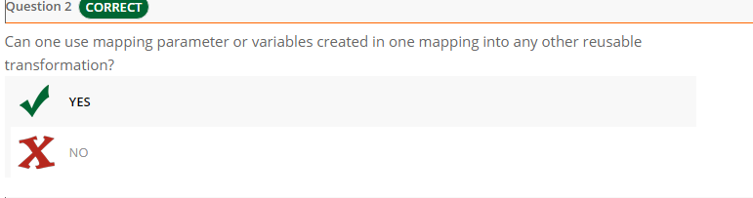

128) 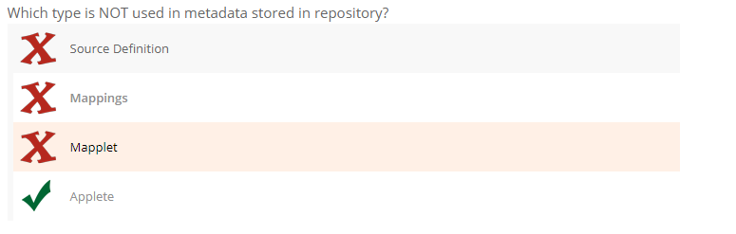

129) 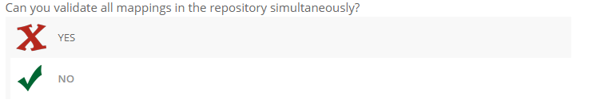

130) 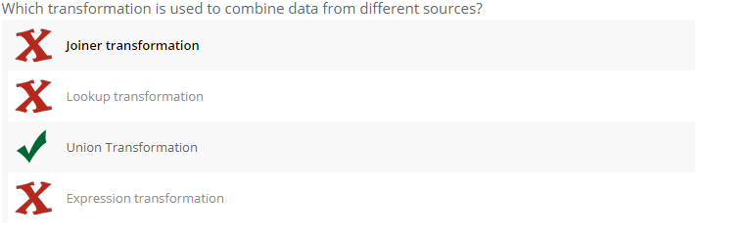

131)

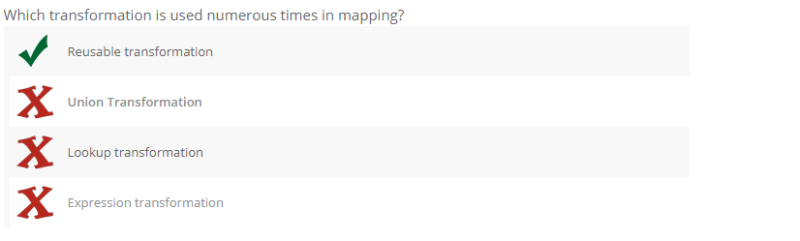

132) 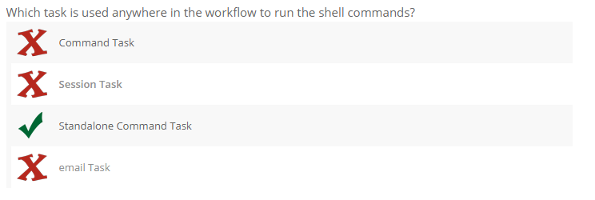

133)

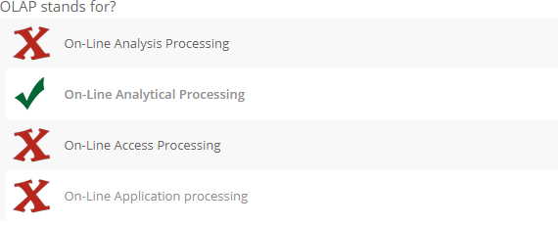

134)

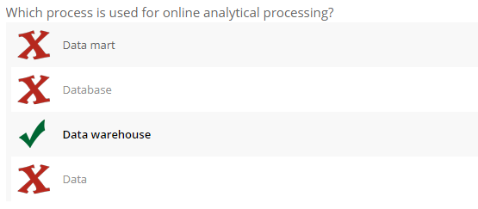

135)

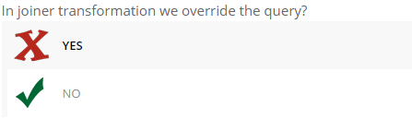

136)

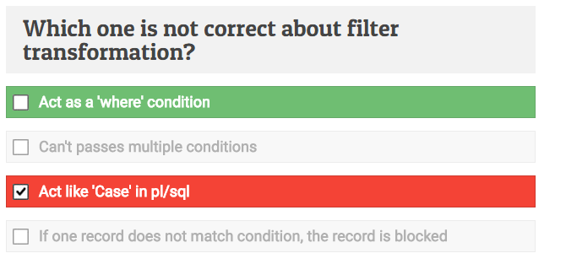

137)

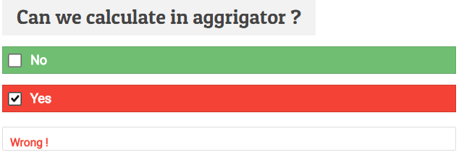

138)

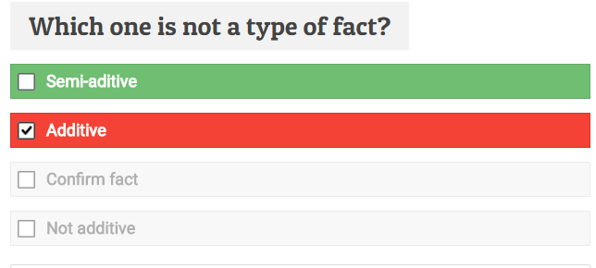

140)

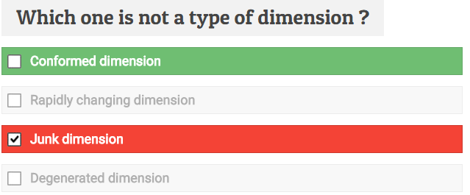

141)

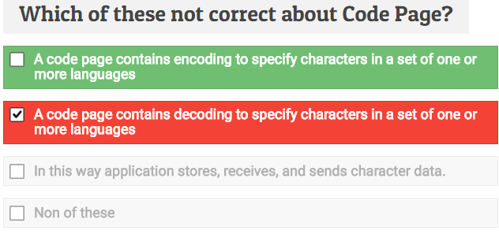

142)

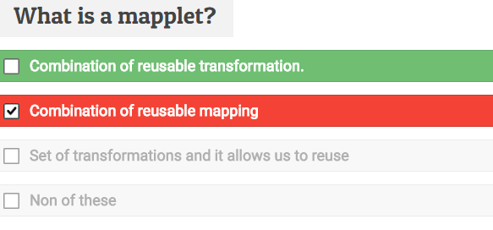

143)

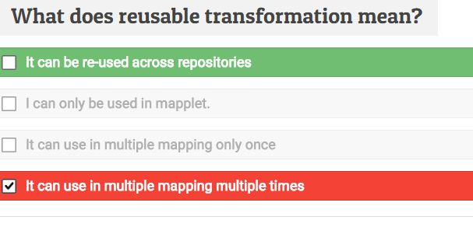

144)

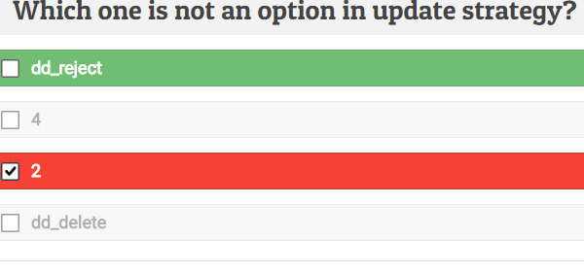

145) 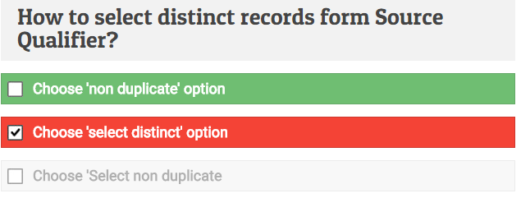

146)

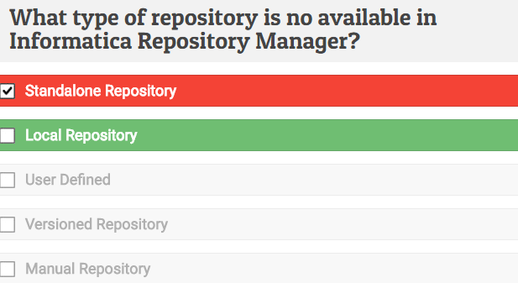

147)

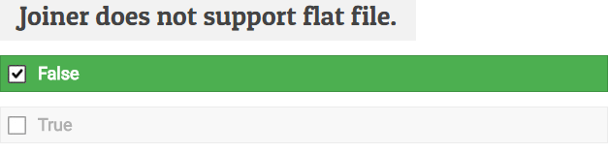

148)

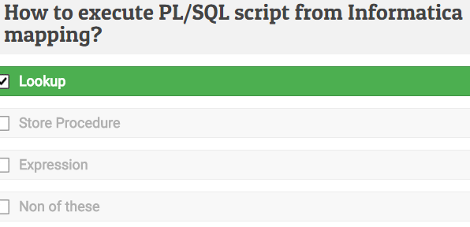

149)

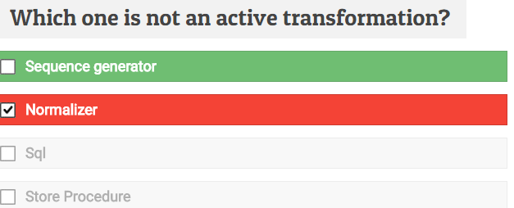

150)